State Testing for Room 15 students

Friday, 5/1, Monday, 5/4, Tuesday, 5/5, Wednesday, 5/6, Friday, 5/8

To become familiar with the test and to take a practice test:

- Log on to : http://www.cde.ca.gov/ta/tg/sa/practicetest.asp
- Scroll down to this and click on the link Take the Practice or Training Test
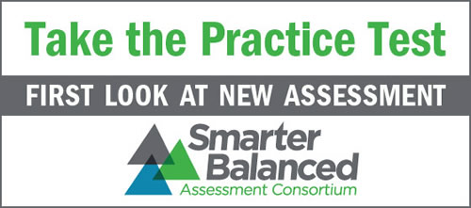
- Sign in as a guest
- Grade: select Grade 3 and click YES
- Pick a math or ELA (English Language) practice test

